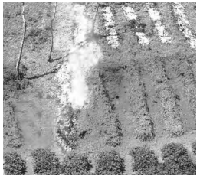
Imagine you are looking at a picture showing a small patch of land where trees have been felled and burned. A farmer is using a simple digging stick to plant seeds in the ash-fertilized soil.
Which type of farming is depicted in this picture?
Match the following:
Column A (Local Name) Column B (State / Region)
I. Bewar A. Western Ghats
II. Podu B. JharkhandIII. Kumari
III. Kumari C. Madhya Pradesh
IV. Kuruwa D. Andhra Pradesh
(a) I - C, II - D, III - A, IV - B
(b) I - D, II - C, III - B, IV - A
(c) I - C, II - A, III - D, IV - B
(d) I - A, II - D, III - C, IV – B

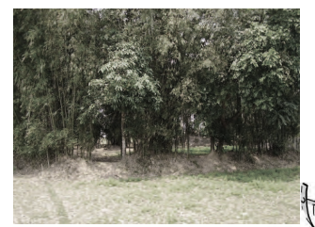
2. A. Name the type of agriculture shown in picture?
B. Why is it called commercial agriculture?
C. Mention essential non geographical conditions for this type of agriculture.
D. Name the area where it is practiced.

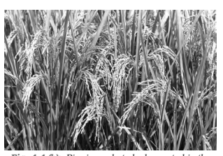
3.

